**DATABASE MANAGEMENT SYSTEMS PROJECT:**

**PROJECT 9**

**HOTEL MANAGEMENT SYSTEM**

**BY**

**SIDDHARTH S SHAH**

**(2021A7PS2428P)**

**RIJUL BASSAMBOO**

**(2021A7PS0009P)**

**The Enitity-Relationship Model is as follows:**

We have listed a few assumptions as well for better understanding.

**Explanations and Assumptions:**

1. A reservation will be booked under a single guest, like in a typical hotel. If a guest needs to book multiple rooms simultaneously, he will have to do it under different reservations.
2. Room capacity is a derived attribute of Room type.
3. For the notation used to describe the cardinality of the ternary relationship Reservation, please refer to the link below:

<https://stackoverflow.com/questions/18365870/er-diagram-ternary-relationship-how-to-read-properly>

1. The bill will be generated only after checkout.
2. For allotting staff to a room, we have decided to go with a more realistic approach. We will be assigning random staff for a particular room service.
3. If the staff member leaves the hotel, then position becomes NULL.
4. For names of tables, views and columns, we have used First letter capitalised camel casing, however in mySQL , since it is case insensitive, we haven’t used any such casing.
5. For names of Procedures, Functions and Triggers we have used the special character ‘_’, which separates the words inside the name. Eg: “Check_out_generate_bill”
6. For revenue calculation, only the rooms which have been checked-out have been considered.

**The initial Relational Diagram is as follows:**

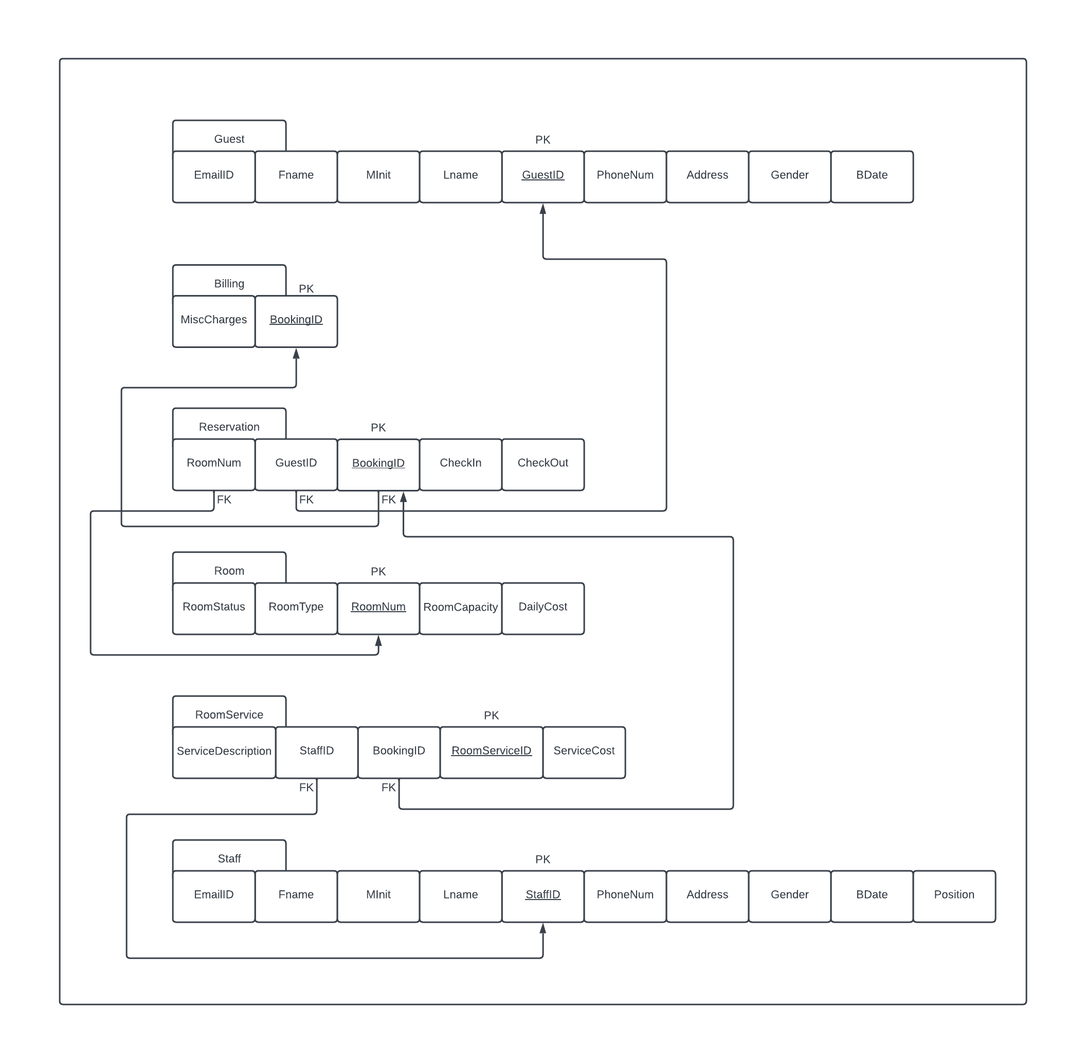

**The following are the constraints that need to be taken care of:**

* **Table Guest:**  
  EmailID varchar(50) NOT NULL,  
  Fname varchar(50) NOT NULL,  
  MInit char,  
  Lname varchar(50) NOT NULL,  
  GuestID int unsigned NOT NULL AUTO_INCREMENT PRIMARY KEY,  
  PhoneNum numeric constraint max_length CHECK (length(PhoneNum)=10) NOT NULL,  
  Gender char NOT NULL,  
  BDate date,  
  Address varchar(255) NOT NULL
* **Table Staff:**  
  EmailID varchar(50) NOT NULL,  
  Fname varchar(50) NOT NULL,  
  MInit char,  
  Lname varchar(50) NOT NULL,  
  StaffID int unsigned NOT NULL AUTO_INCREMENT PRIMARY KEY,  
  PhoneNum numeric constraint max_length CHECK (length(PhoneNum)=10) NOT NULL,  
  Gender char NOT NULL,  
  BDate date,  
  Address varchar(255) NOT NULL,  
  Position varchar(30) NOT NULL
* **Table Billing:**

MiscCharges int(20),

BookingID int unsigned NOT NULL AUTO_INCREMENT,

PRIMARY KEY (BookingID)

* **Table Room:**  
  RoomStatus bool default false,  
  RoomType varchar(20),  
  RoomNum int(5),

DailyCost int(10) NOT NULL,  
RoomCapacity int (2),  
RoomType varchar(20),  
PRIMARY KEY (RoomNum)

* **Table Reservation:**

RoomNum int(5),

GuestID int unsigned,

BookingID int unsigned,

CheckIn TIMESTAMP NOT NULL default current_timestamp,

CheckOut TIMESTAMP default NULL,

PRIMARY KEY (BookingID),

FOREIGN KEY (GuestID) REFERENCES Guest(GuestID),

FOREIGN KEY (RoomNum) REFERENCES Room(RoomNum)

FOREIGN KEY (BookingID) REFERENCES Billing(BookingID)

* **Table RoomService:**

ServiceDescription varchar(255) NOT NULL,

StaffID int unsigned,

BookingID int unsigned,

RoomServiceID int unsigned NOT NULL AUTO_INCREMENT,

ServiceCost float (10,2),

PRIMARY KEY (RoomServiceID),

FOREIGN KEY (StaffID) REFERENCES Staff(StaffID),

FOREIGN KEY (BookingID) REFERENCES Reservation_Billing(BookingID)

Next page

**Step-1: Removal of Redundancy**

As the PK of both the Billing and Reservation Table is the same, we can merge the tables.

We will create separate views for them independently from this table.

The name of the new table will be Reservation_Billing and the attributes will be RoomNum, GuestID, BookingID, CheckIn, CheckOut and MiscCharges.

Here is the updated Relational Diagram.

**Changes after Step-1:**

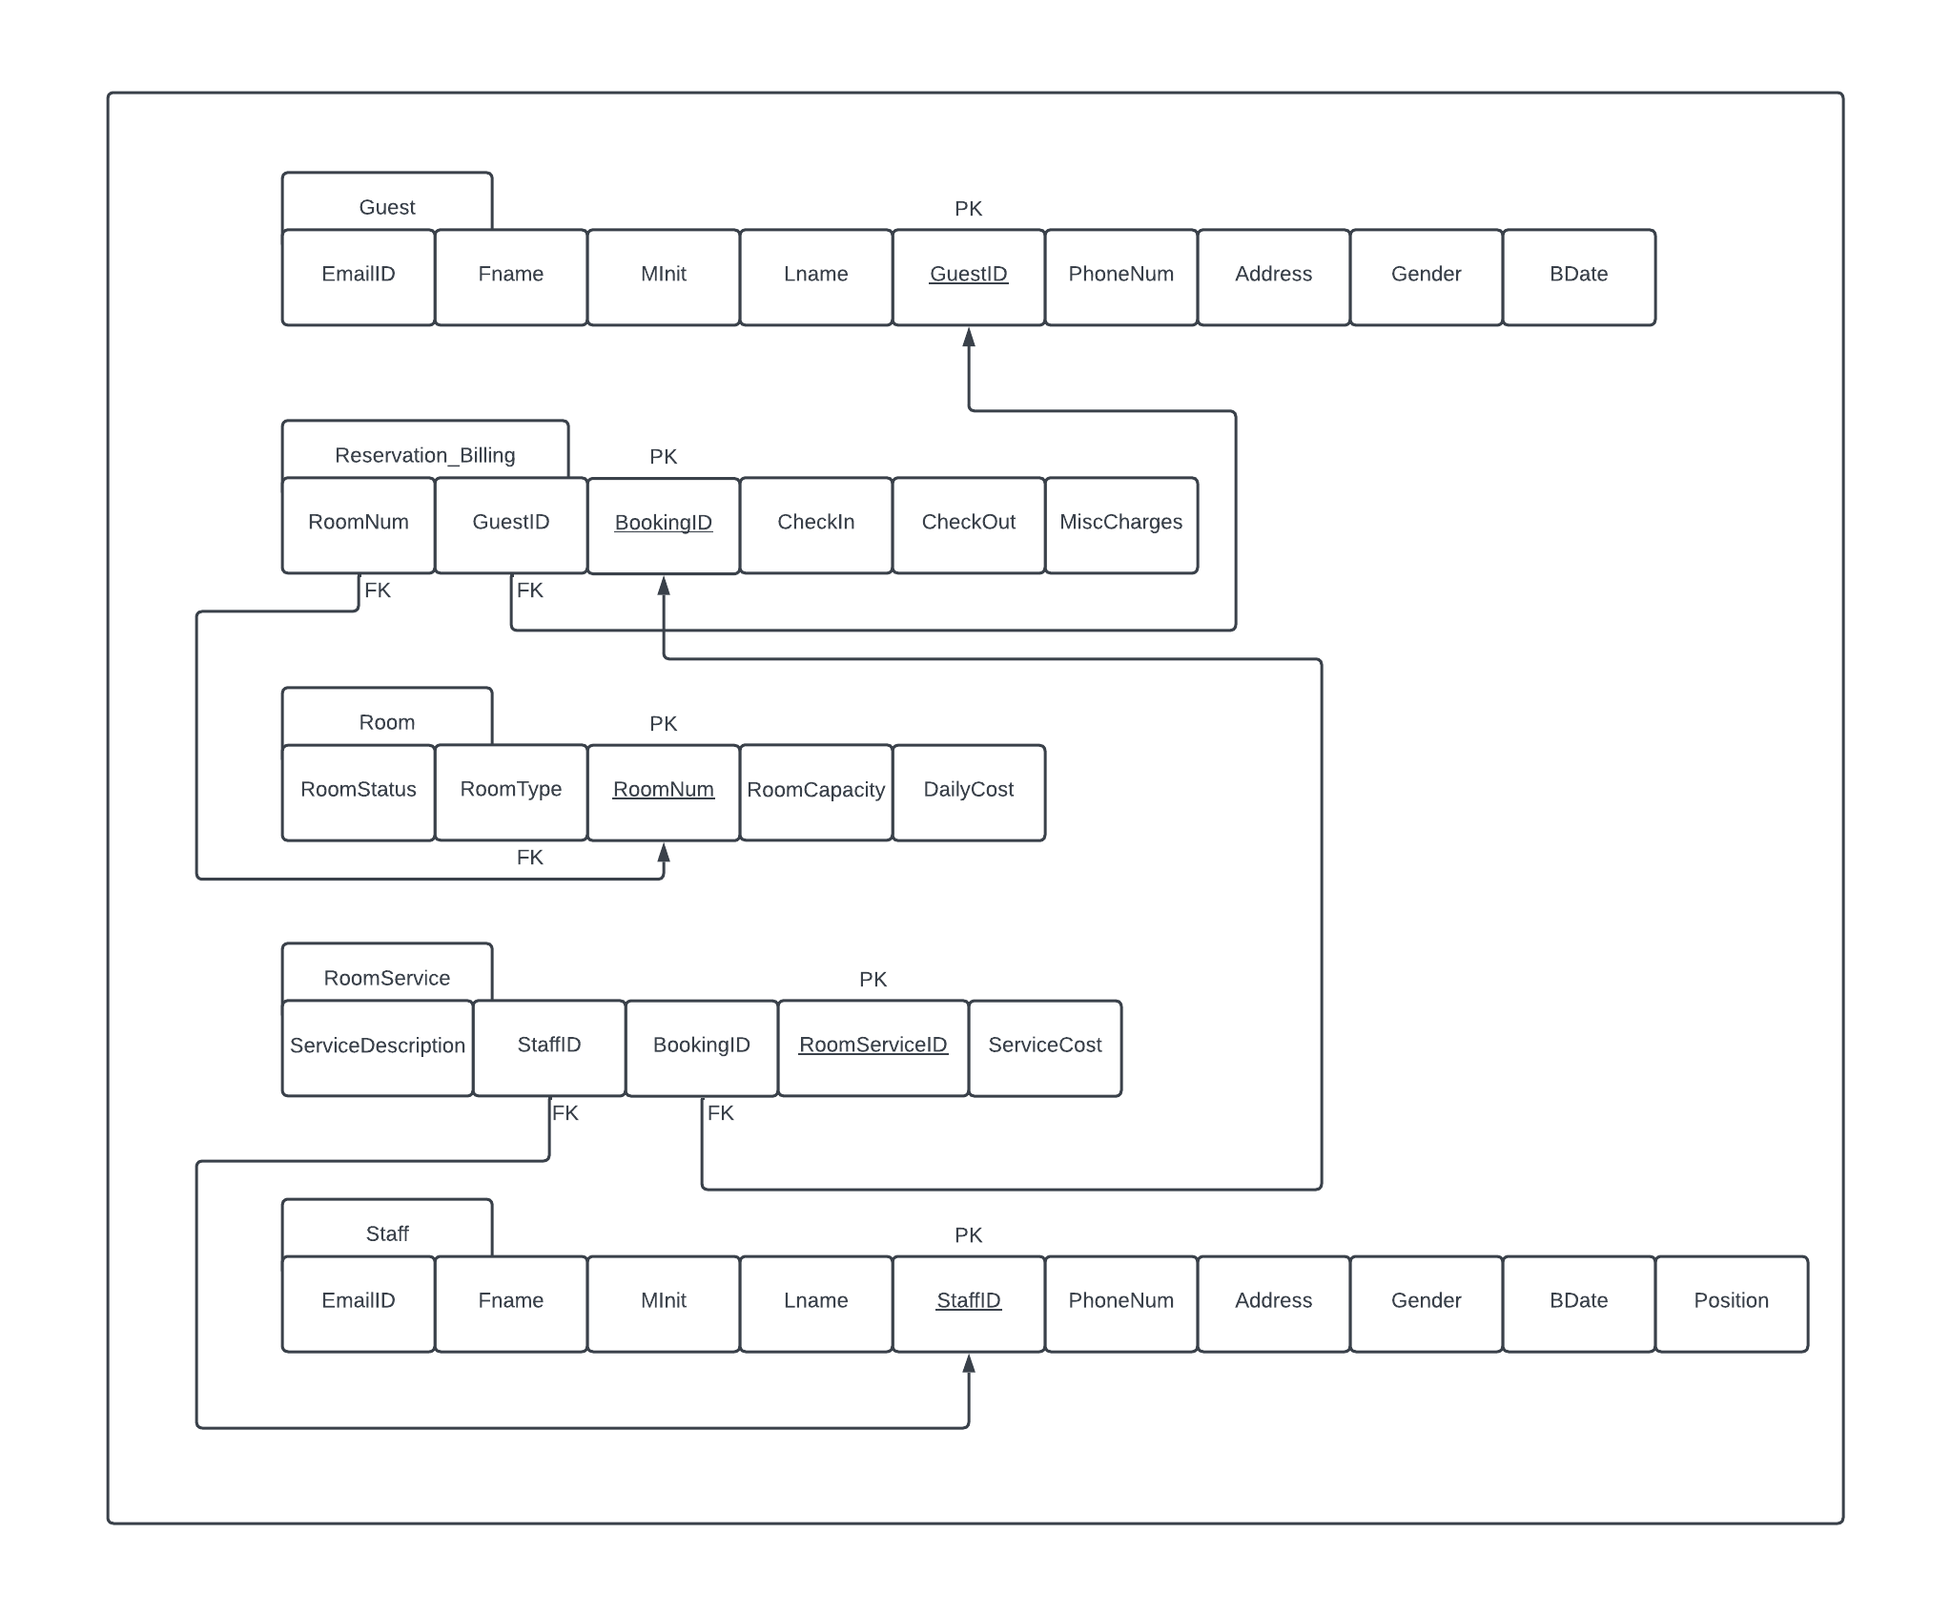

**Now, to check whether the Schema is in 1NF, 2NF and finally 3NF:**

**1NF:**

**Table GuestID:**

GuestID (PK) 🡪EmailID, Fname, Lname, MInit, PhoneNum, Address, Gender, BDate

**Table Reservation_Billing:**

BookingID (PK) 🡪RoomNum(FK), GuestID(FK), CheckIn, CheckOut, MiscCharges

**Table Room:**

RoomNum (PK) 🡪RoomStatus, RoomType, RoomCapacity, DailyCost

**Table** **RoomService**:

RoomServiceID (PK) 🡪ServiceDescription, StaffID(FK), BookingID(FK), ServiceCost

**Table** **Staff**:

StaffID(PK) 🡪EmailID, Fname, Lname, MInit, PhoneNum, Address, Gender, BDate, Position

The given relational schema is already in 1NF as it does not have any multivalued and composite attributes.

Next Page

**2NF:** To check if the schema is in 2NF, let us first list down all the functional dependencies-

**Table GuestID:**

GuestID (PK) 🡪EmailID, Fname, Lname, MInit, PhoneNum, Address, Gender, BDate

**Table Reservation_Billing:**

BookingID (PK) 🡪RoomNum(FK), GuestID(FK), CheckIn, CheckOut, MiscCharges

**Table Room:**

RoomNum (PK) 🡪RoomStatus, RoomType, RoomCapacity, DailyCost

RoomType 🡪RoomCapacity, DailyCost

**Table** **RoomService**:

RoomServiceID (PK) 🡪ServiceDescription, StaffID(FK), BookingID(FK), ServiceCost

**Table** **Staff**:

StaffID(PK) 🡪EmailID, Fname, Lname, MInit, PhoneNum, Address, Gender, BDate, Position

The given relational schema is already in 2NF as every non-prime attribute in the relations are fully functionally dependent on the primary key. Also, the primary key is composed of a single attribute.

**Next Page**

**3NF:** The relational schema is not in 3NF as the RoomType attribute, which is not a super key, is implying 2 non-prime attributes, namely RoomCapacity and DailyCost. Therefore, we need to decompose the table Room into two tables –

1. Room
2. RoomTypeDetails

The table Room will contain RoomNum (Primary Key), RoomType (which will be the Foreign Key for the table RoomTypeDetails) and RoomStatus.

The table RoomTypeDetails will contain RoomCapacity, RoomType (Primary Key) and DailyCost.

**The final functional dependencies are as follows:**

**Table GuestID:**

GuestID (PK) 🡪EmailID, Fname, Lname, MInit, PhoneNum, Address, Gender, BDate

**Table Reservation_Billing:**

BookingID (PK) 🡪RoomNum(FK), GuestID(FK), CheckIn, CheckOut, MiscCharges

**Table Room:**

RoomNum (PK) 🡪RoomStatus, RoomType

**Table RoomTypeDetails:**

RoomType (PK) 🡪RoomCapacity, DailyCost

**Table** **RoomService**:

RoomServiceID (PK) 🡪ServiceDescription, StaffID(FK), BookingID(FK), ServiceCost

**Table** **Staff**:

StaffID(PK) 🡪EmailID, Fname, Lname, MInit, PhoneNum, Address, Gender, BDate, Position

Since, there are no transitive relations in the schema, hence the relational schema is in 3NF.

**Here is the final Relational Schema in 3NF.**

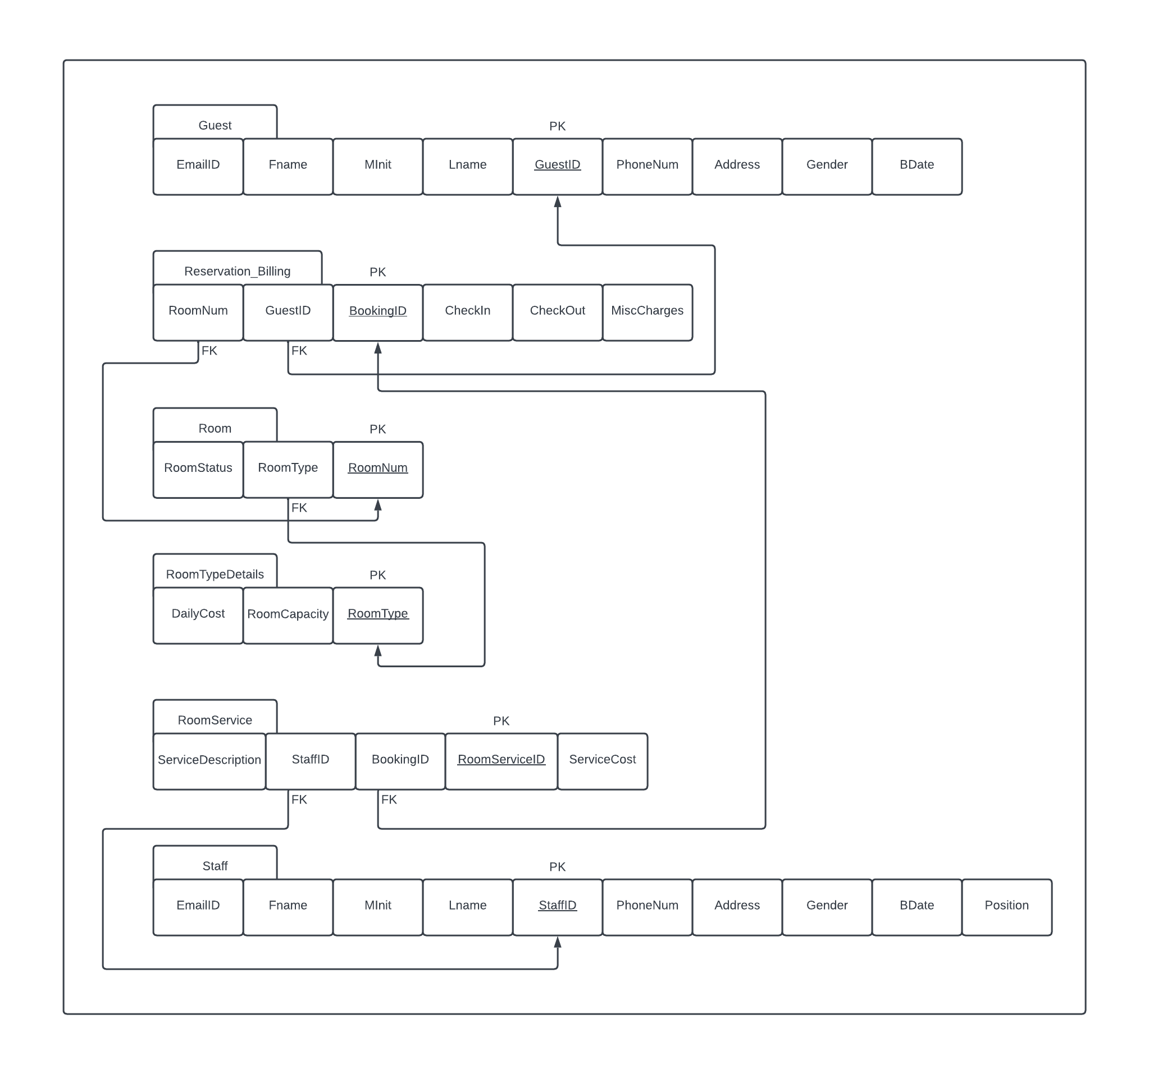

**The final constraints are as follows:**

* **Table Guest:**  
  EmailID varchar(50) NOT NULL,  
  Fname varchar(50) NOT NULL,  
  MInit char,  
  Lname varchar(50) NOT NULL,  
  GuestID int unsigned NOT NULL AUTO_INCREMENT PRIMARY KEY,  
  PhoneNum numeric constraint max_length CHECK (length(PhoneNum)=10) NOT NULL,  
  Gender char NOT NULL,  
  BDate date,  
  Address varchar(255) NOT NULL
* **Table Staff:**  
  EmailID varchar(50) NOT NULL,  
  Fname varchar(50) NOT NULL,  
  MInit char,  
  Lname varchar(50) NOT NULL,  
  StaffID int unsigned NOT NULL AUTO_INCREMENT PRIMARY KEY,  
  PhoneNum numeric constraint max_length CHECK (length(PhoneNum)=10) NOT NULL,  
  Gender char NOT NULL,  
  BDate date,  
  Address varchar(255) NOT NULL,  
  Position varchar(30) NOT NULL
* **Table RoomTypeDetails:**DailyCost int(10) NOT NULL,  
  RoomCapacity int (2),  
  RoomType varchar(20) PRIMARY KEY
* **Table Room:**  
  RoomStatus bool default false,  
  RoomType varchar(20),  
  RoomNum int(5),  
  PRIMARY KEY (RoomNum),  
  FOREIGN KEY (RoomType) REFERENCES RoomTypeDetails(RoomType)
* **Table Reservation_Billing:**

RoomNum int(5),

GuestID int unsigned,

BookingID int unsigned NOT NULL AUTO_INCREMENT,

CheckIn TIMESTAMP NOT NULL default current_timestamp,

CheckOut TIMESTAMP default NULL,

MiscCharges int(20),

PRIMARY KEY (BookingID),

FOREIGN KEY (GuestID) REFERENCES Guest(GuestID),

FOREIGN KEY (RoomNum) REFERENCES Room(RoomNum)

* **Table RoomService:**

ServiceDescription varchar(255) NOT NULL,

StaffID int unsigned,

BookingID int unsigned,

RoomServiceID int unsigned NOT NULL AUTO_INCREMENT,

ServiceCost float(10,2),

PRIMARY KEY (RoomServiceID),

FOREIGN KEY (StaffID) REFERENCES Staff(StaffID),

FOREIGN KEY (BookingID) REFERENCES Reservation_Billing(BookingID)

**NOTE: Casing Convention:**

**SQL Queries and their Explanation:**

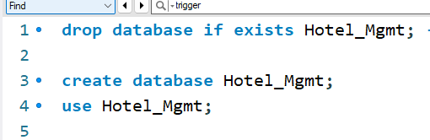

* drop command is used to drop any pre-existing database with the name “Hotel_mgmt”
* create database and use db_name are used to create and finally use the database “Hotel_mgmt”

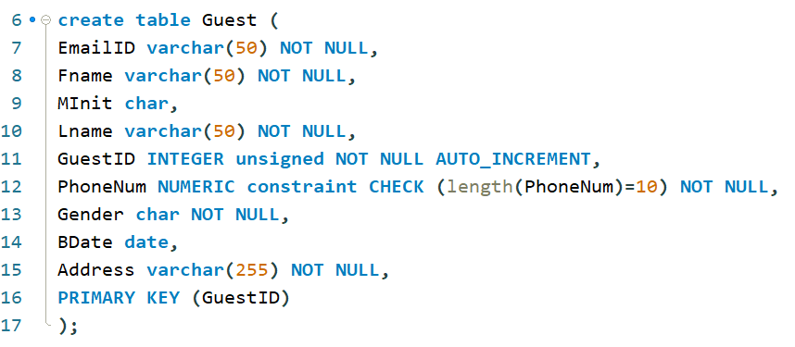

* create table command is used to make a table inside the database. Here the table with the tb_name ‘guest’ is being made which has many attributes and their corresponding constraints.

* Here the table with the tb_name ‘Staff’ is being made which has many attributes and their corresponding constraints.

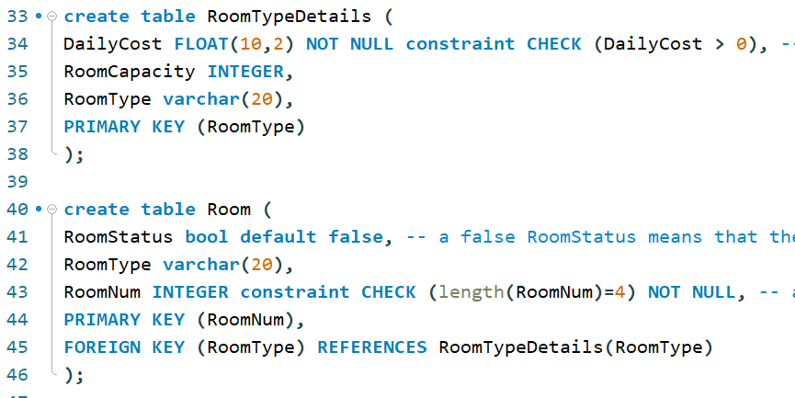

* Here the tables with the tb_name ‘RoomTypeDetails’ and ‘Room’ are being made which have many attributes and their corresponding constraints.

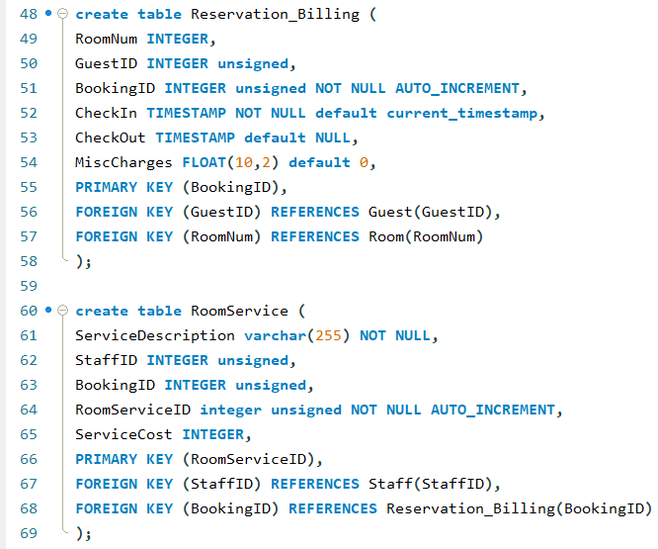

* Here the tables with the tb_name ‘Reservation_Billing’ and ‘Room’ are being made which have many attributes and their corresponding constraints.

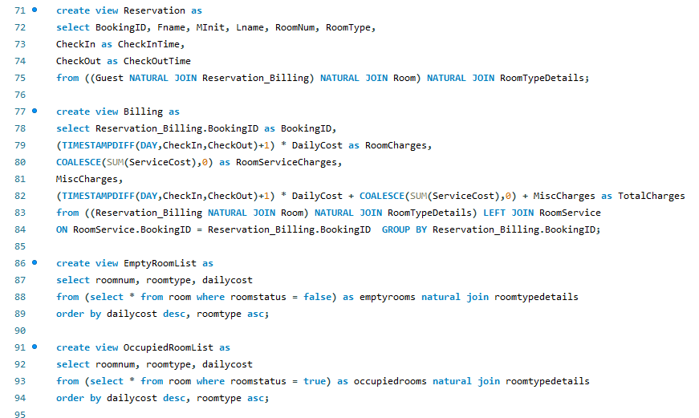

* Here we have made 4 views. Namely Reservation, Billing, EmptyRoomList and OccupiedRoomList.
* The Reservation view displays a few of the guest details, booking details and room details.
* The Billing view displays the bills generated per booking including room charges, room service charges, miscellaneous charges, and total charges.
* The EmptyRoomList view displays the list of the rooms which haven’t been occupied.
* The occupiedRoomList view displays the list of the rooms which have been occupied.

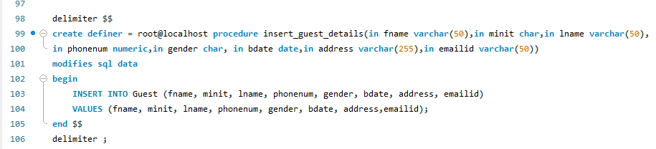

* The insert_guest_details procedure is used to enter the guest details into the Guest table.

* The insert_staff_details procedure is used to enter the staff details into the Staff table.

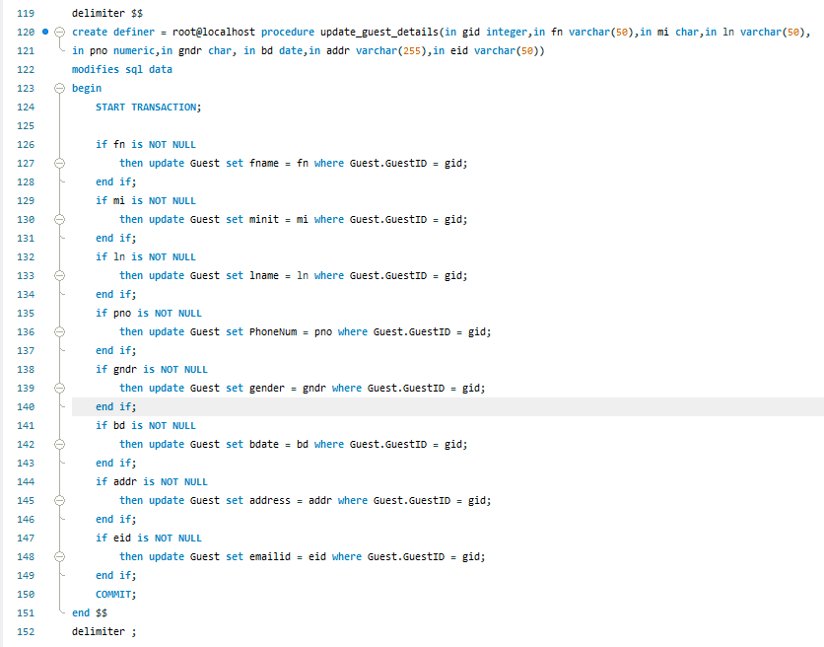

* The update_guest_details procedure is used to update the guest details. It checks if the passed parameter is null or not and then accordingly updates the passed parameters.

* The update_staff_details procedure is used to update the staff details. It checks if the passed parameter is null or not and then accordingly updates the passed parameters.

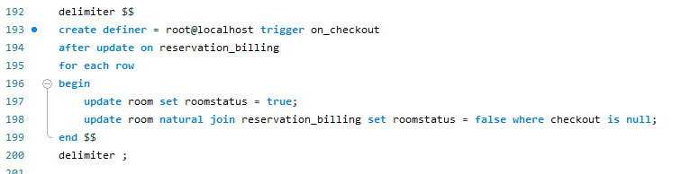

* The on_checkout trigger updates the room status to false once the checkout is set to null. This happens after any updation to the reservation_billing table.

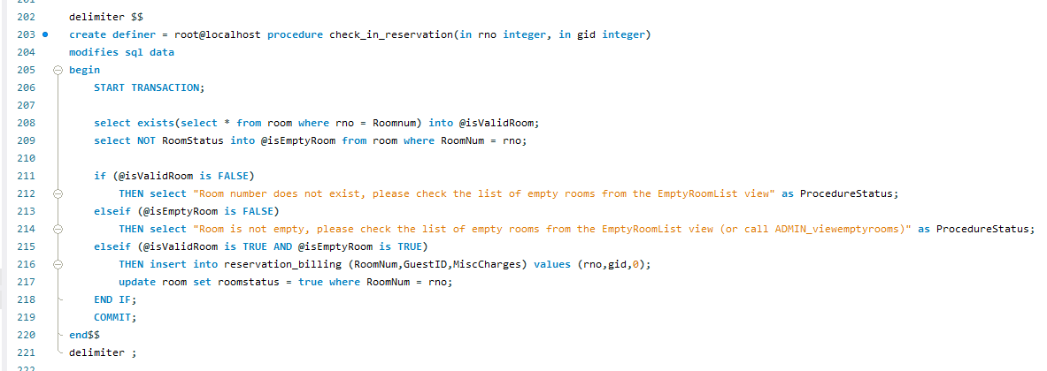

* The check_in_reservation procedure does the check-in for the guests. It takes two parameters, the room number and the guest id.

* The check_out_generate_bill procedure is used to the generate the bill for the guest who has checked out of the hotel. It takes the booking id as a parameter.

* The cancel_booking procedure is used to cancel the booking of a guest. It takes booking id as a parameter.

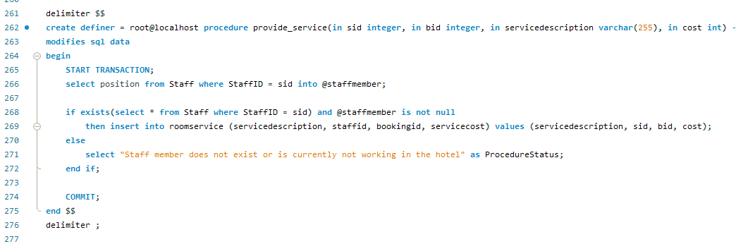

* The provide_service is a procedure which is used to add the records of any room service being provided to the guests. It takes the staff id, booking id, service description and the cost of the service as its parameters.

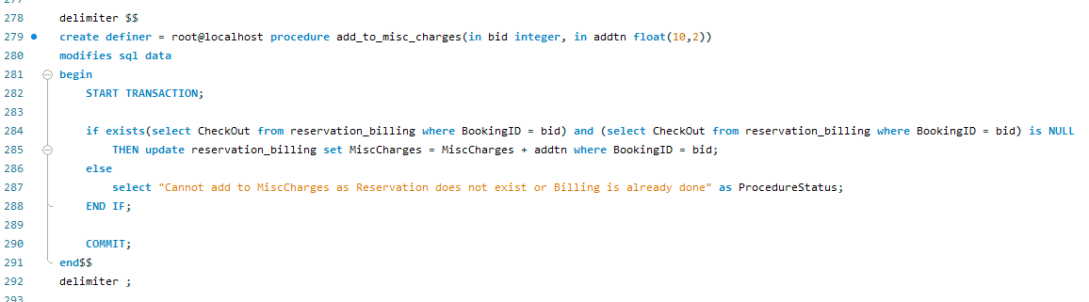

* The add_to_misc_charges is the procedure used to add any kind of miscellaneous charge under the guest’s tab. It takes the booking id and the amount to be added (cost) as its parameters.

* The ADMIN_viewemptyrooms procedure is used to view all the rooms which are empty.
* The ADMIN_viewoccupiedrooms procedure is used to view all the rooms which are occupied.
* The ADMIN_revenuefromtype procedure is used to derive the revenue generated from each room type.

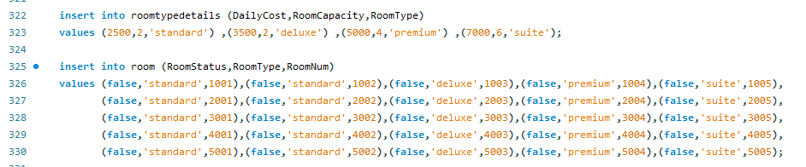

* Inserting the room and roomtype details.

* Inserting the guest details.

* Inserting the staff details.

* Calling the check_in_reservations procedure to check-in the guests.

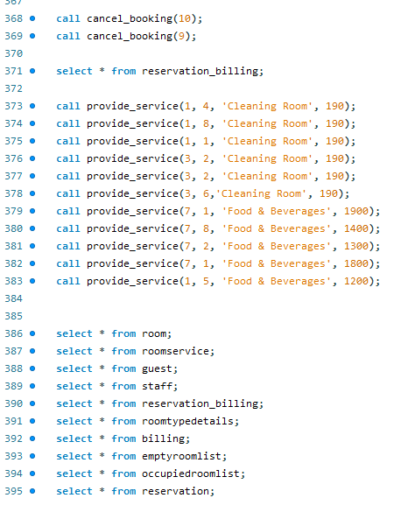

* Calling the cancel_booking procedure.
* Calling the provide_service procedure.
* Select commands for viewing the contents of the different tables.

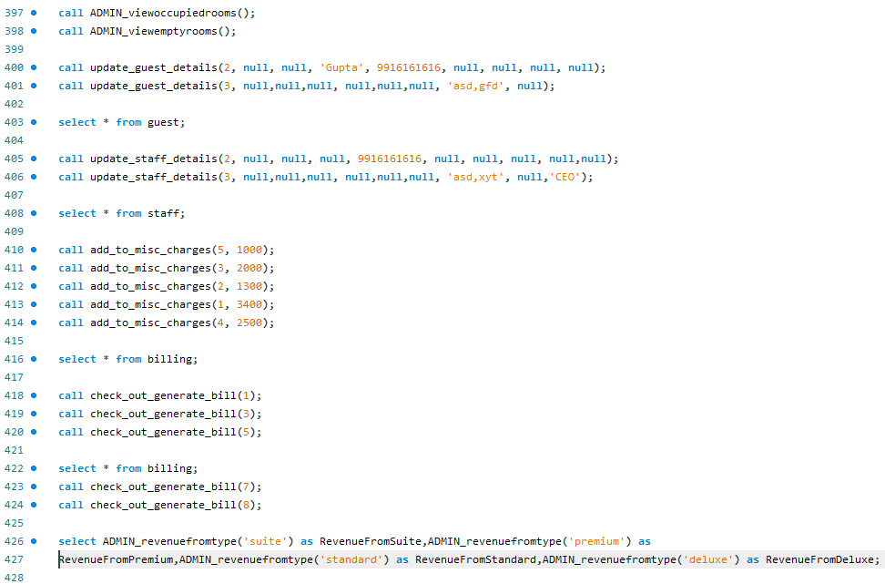

* Calling ADMIN view empty and occupied room procedures.
* Calling the update guest details procedure.
* Calling the add to misc. charges procedure.
* Calling the check_out_generate_bill procedure.
* Calling the ADMIN_revenuefromtoye procedure.

**SCREENSHOT OF OUTPUTS:**

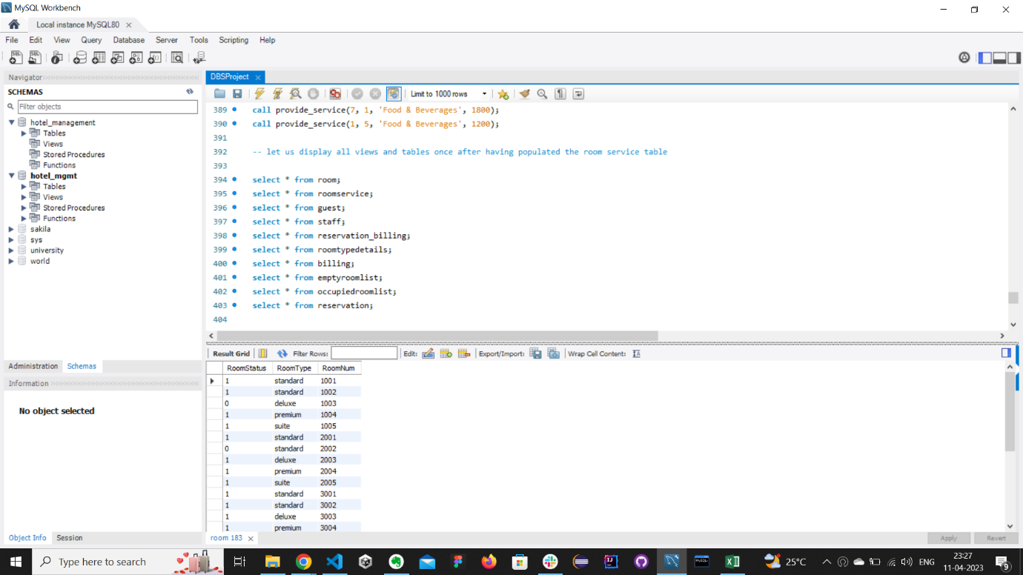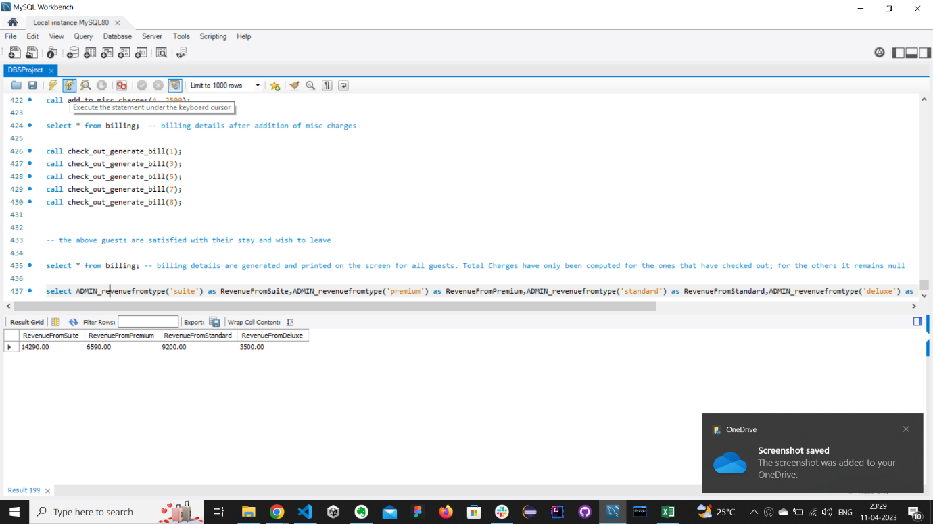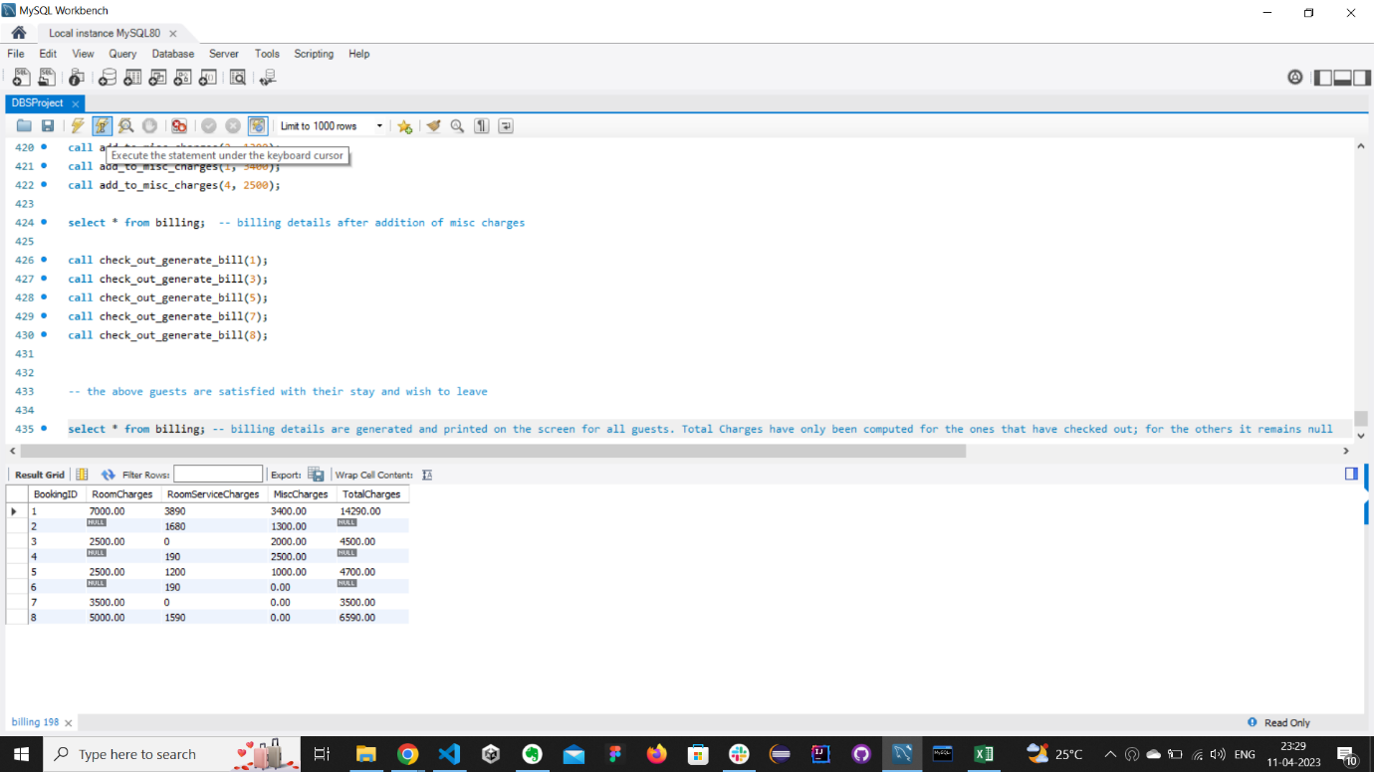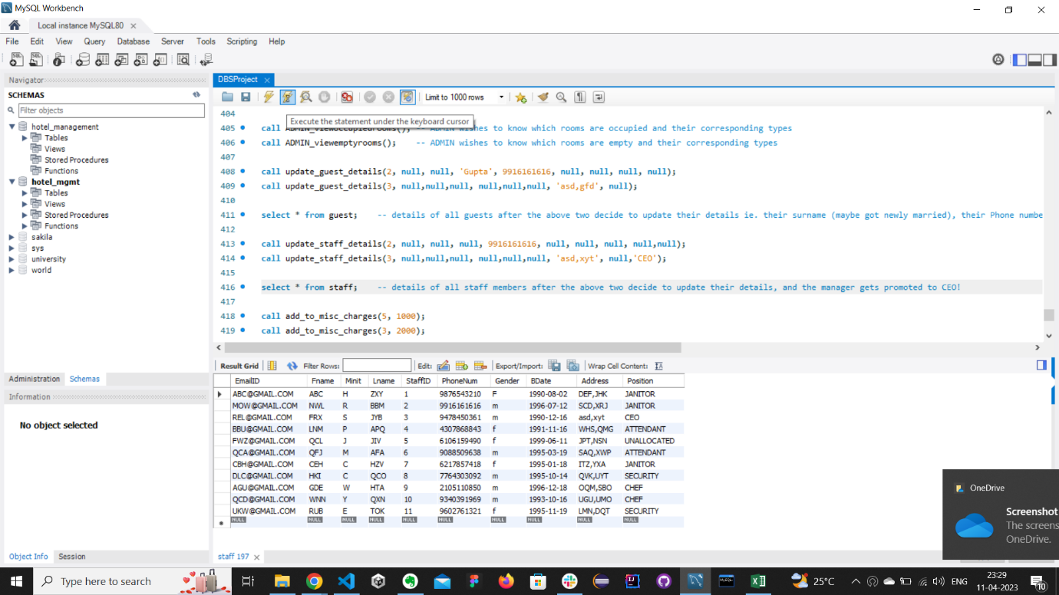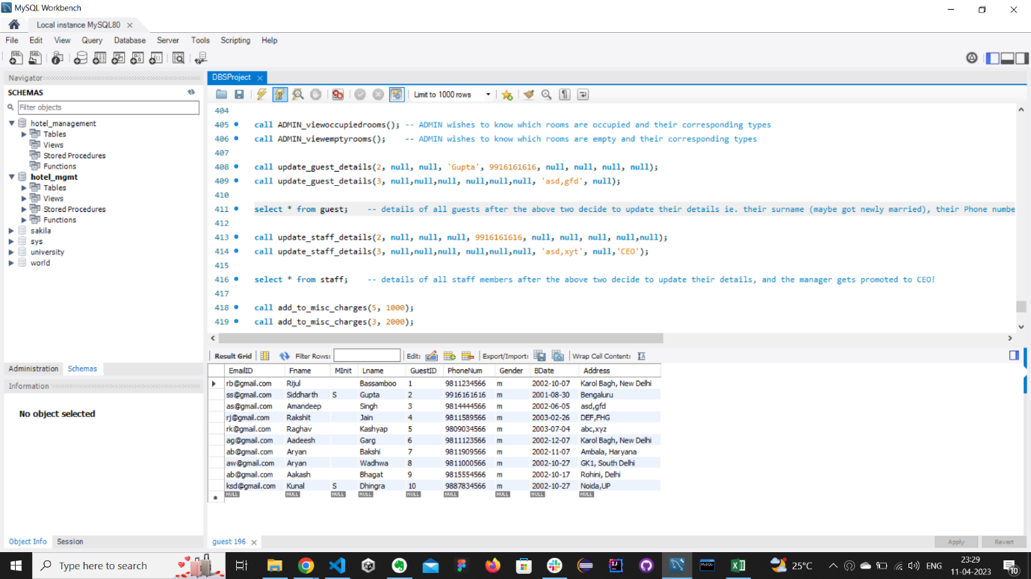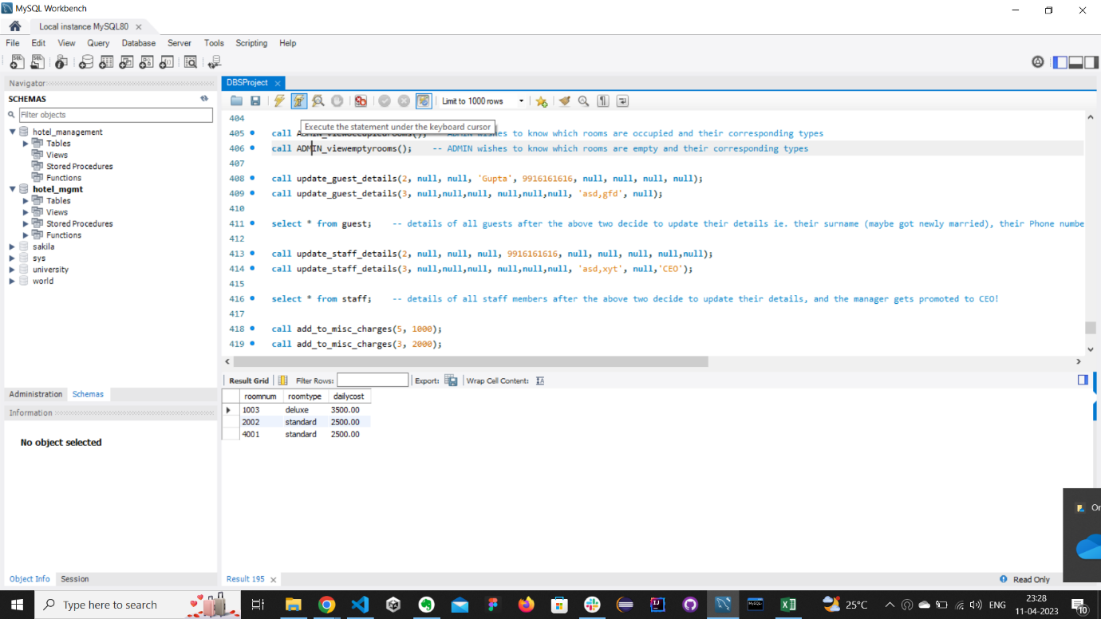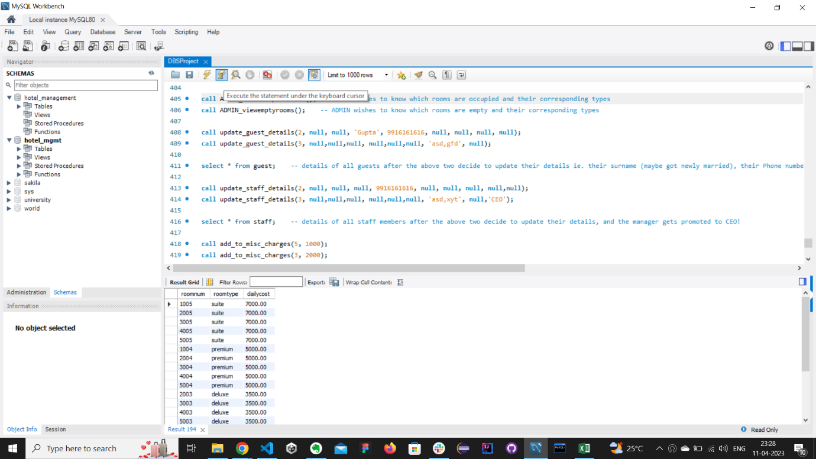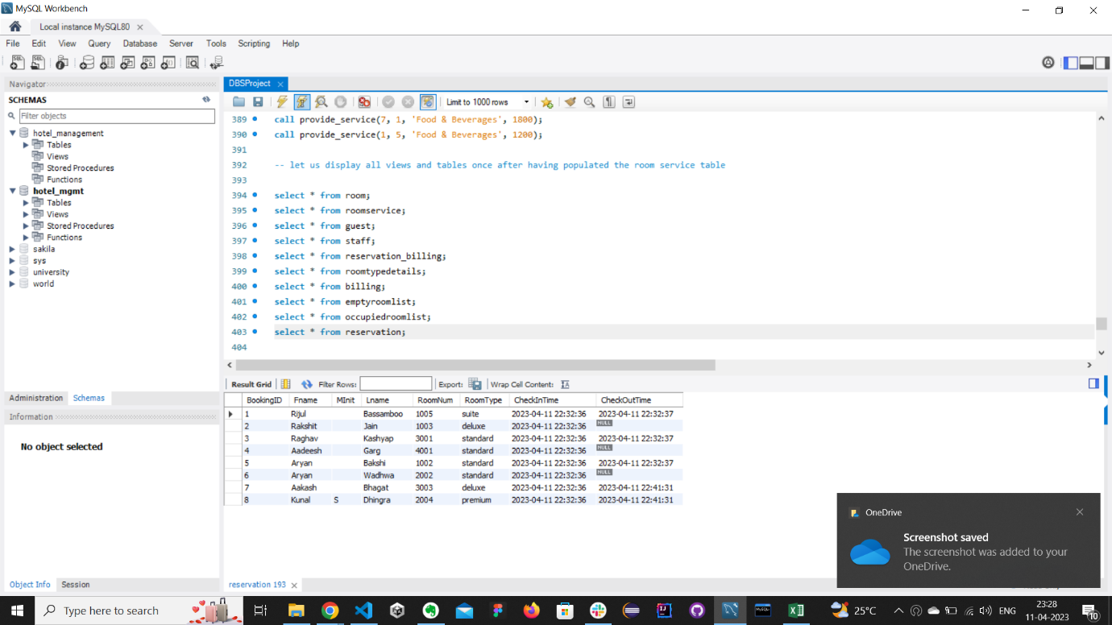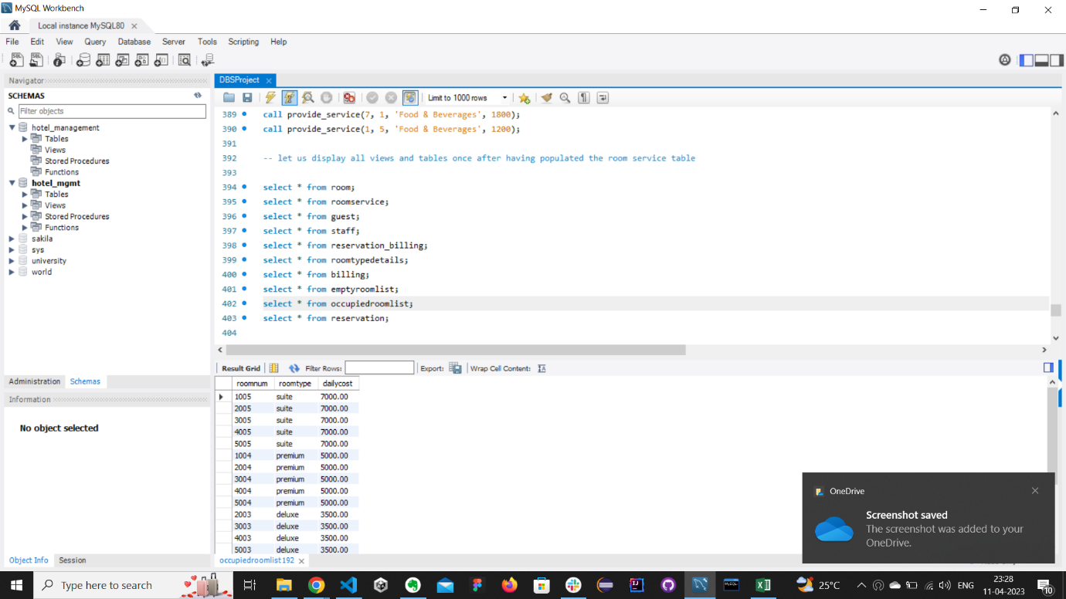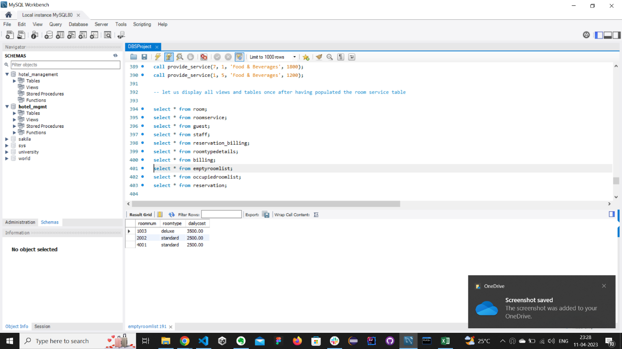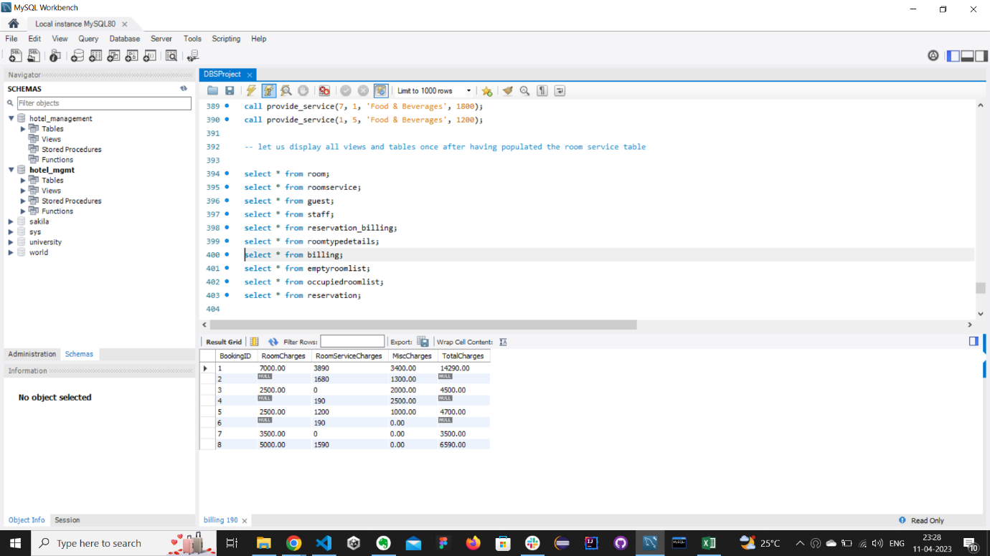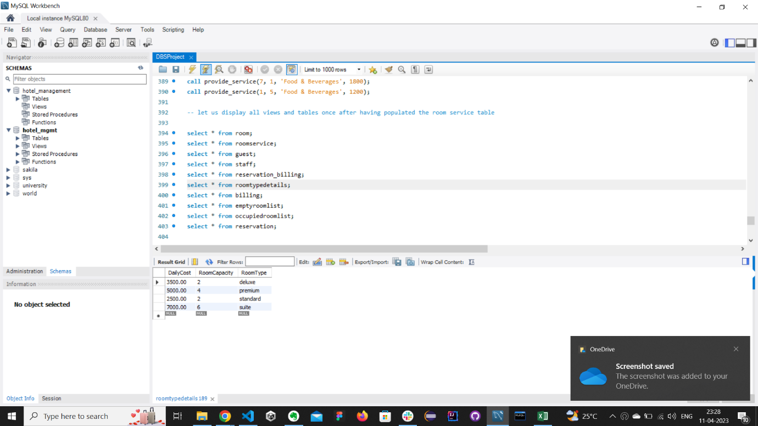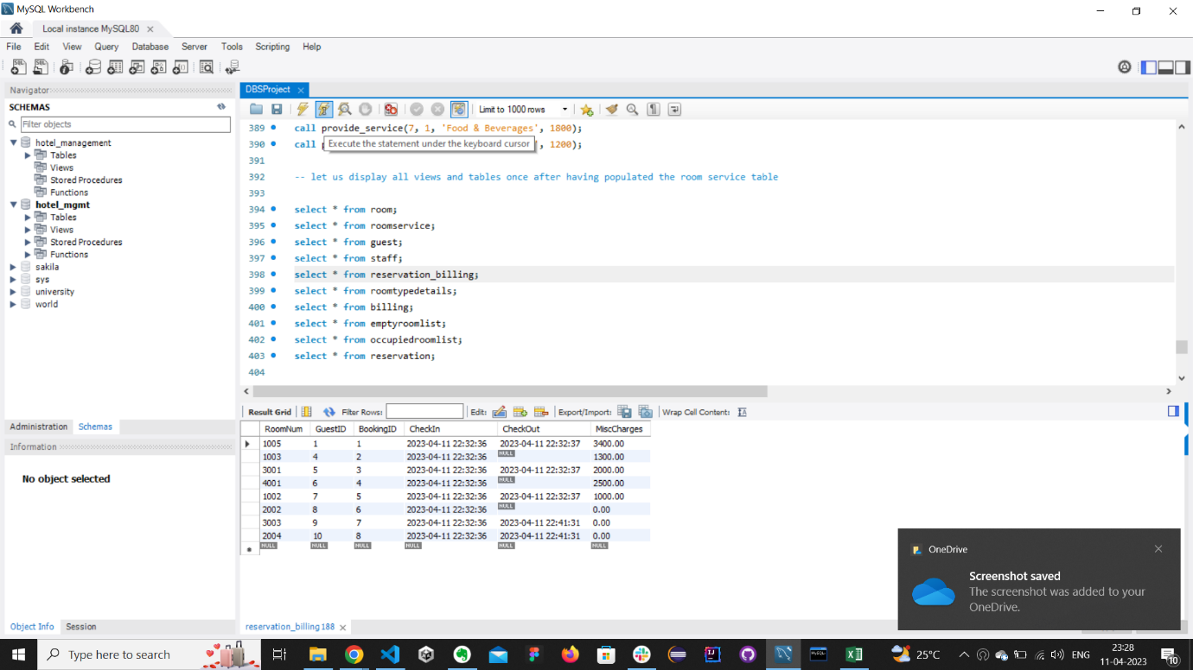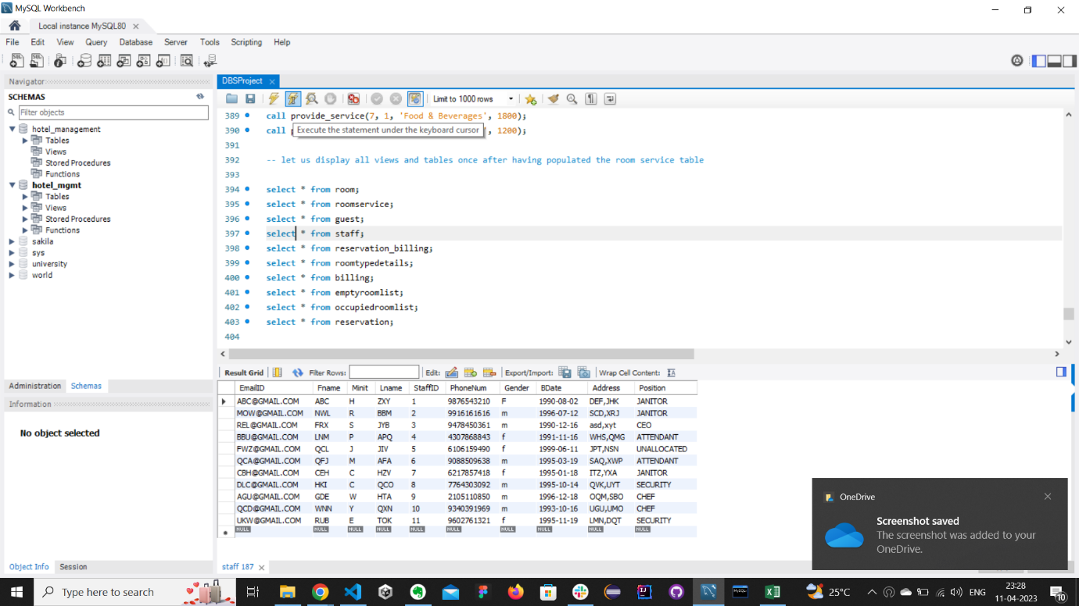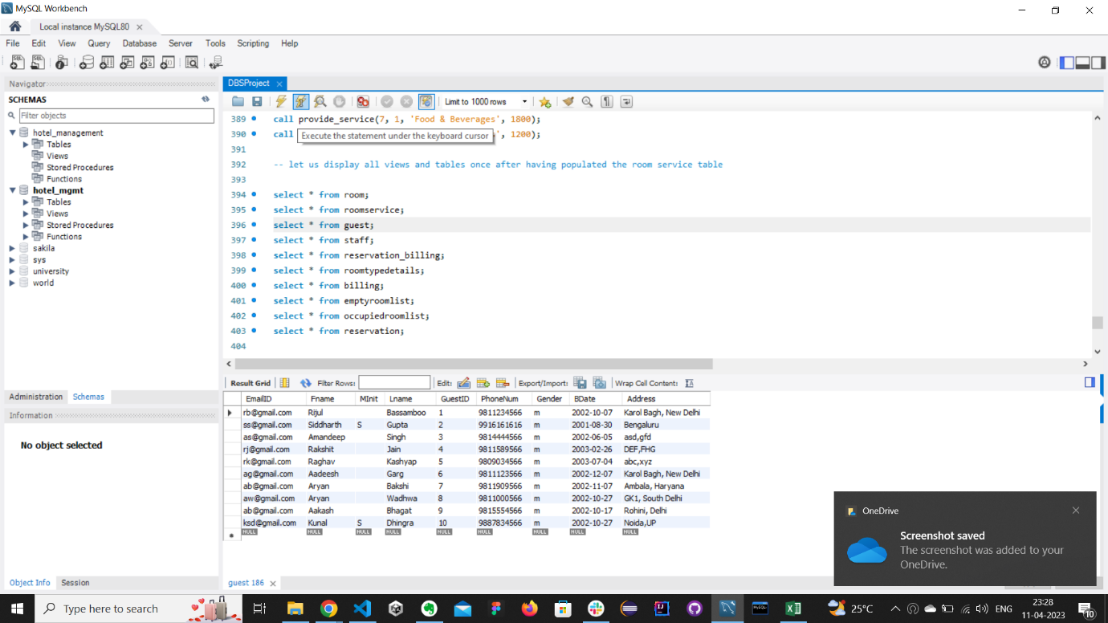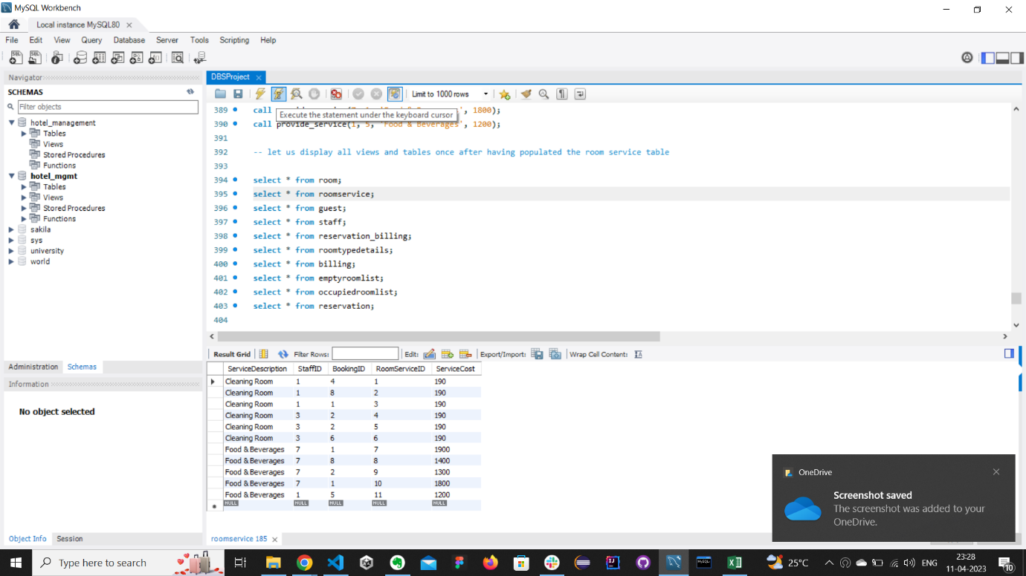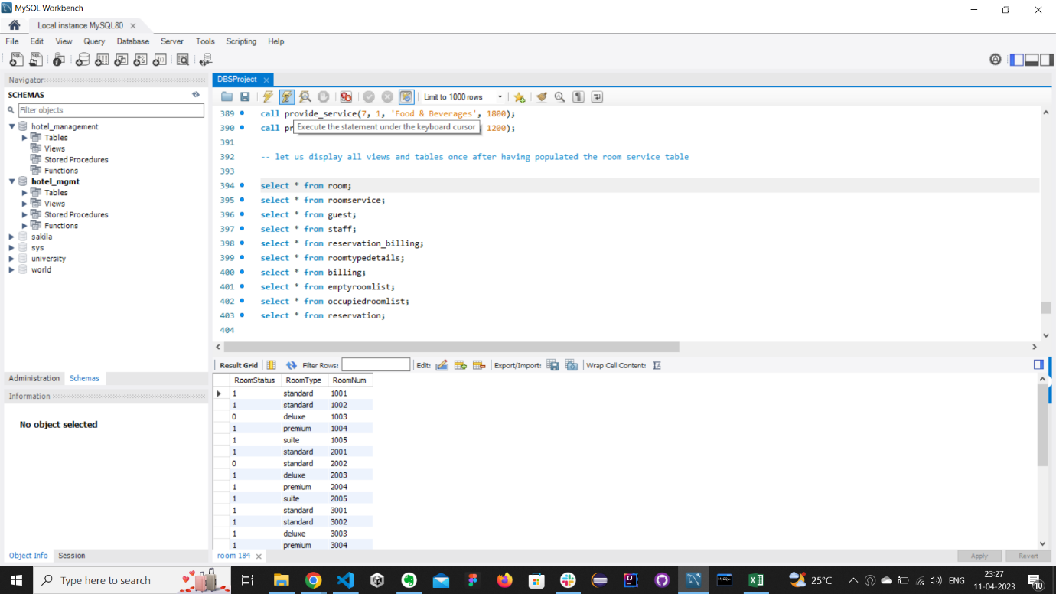

**Google Drive Link –** [**https://drive.google.com/drive/folders/1KTGc0iUG7BoXE7yj2xmGamtXb6wsm8nk**](https://drive.google.com/drive/folders/1KTGc0iUG7BoXE7yj2xmGamtXb6wsm8nk)

**The End.**

**Thank you.**